import java.util.Scanner;
class Test
{
public static void main(String args[])
{
Scanner s=new Scanner(System.in);
System.out.println("enter the value");
int a=s.nextInt();
for(int i=1;i<=a;i++)
{
for(int j=1;j<=a;j++)
{
if((i==j)||((i+j)==(a+1)))
{
System.out.print("*");
}
else
{
System.out.print(" ");
}
}
System.out.println();
}
}
}
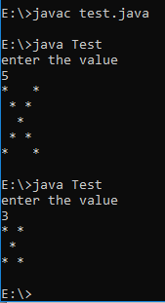
import java.util.Scanner;
class Test
{
public static void main(String args[])
{
Scanner s=new Scanner(System.in);
System.out.println("enter the value");
int a=s.nextInt();
int b=1;
for(int i=1;i<=a;i++)
{
for(int j=1;j<=a;j++)
{
if((j>=b)&&(j<=(a-b+1)))
{
System.out.print("*");
}
else
{
System.out.print(" ");
}
}
System.out.println();
if(i<=(a/2))
{
b++;
}
else
{
b--;
}
}
}
}
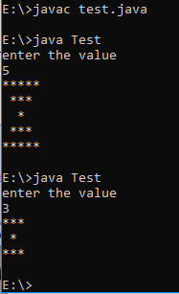
import java.util.Scanner;
class Test
{
public static void main(String args[])
{
Scanner s=new Scanner(System.in);
System.out.println("enter the value");
int a=s.nextInt();
int b=1;
for(int i=1;i<=a;i++)
{
for(int j=1;j<=a;j++)
{
if((j<=b)||(j>=(a-b+1)))
{
System.out.print("*");
}
else
{
System.out.print(" ");
}
}
System.out.println();
if(i<=(a/2))
{
b++;
}
else
{
b--;
}
}
}
}
